**AMERICAN** **INTERNATIONAL** **UNIVERSITYBANGLADESH** **Faculty** **of** **Engineering**

**Laboratory** **Report** **Cover** **Sheet**

***Students*** ***must*** ***complete*** ***all*** ***details*** ***except*** ***the*** ***faculty*** ***use*** ***part.***

Please submit all reports to your subject supervisor or the office of the concerned faculty.

Laboratory Title: Study of signal frequency, spectrum, bandwidth, and quantization using MATLAB

Experiment Number: 2 Due Date: 12/10/2022 Semester: Fall 2022-23

Subject Code: COE3103 Subject Name: Data Communication Section: K Course Instructor: Dr. Shuvra Mondal Degree Program: B.Sc. in CSE

**Declaration** **and** **Statement** **of** **Authorship:**

1. I/we hold a copy of this report, which can be produced if the original is lost/ damaged.

2. This report is my/our original work and no part of it has been copied from any other student’s work or from any other source except where due acknowledgement is made.

3. No part of this report has been written for me/us by any other person except where such collaboration has been authorized by the lecturer/teacher concerned and is clearly acknowledged in the report.

4. I/we have not previously submitted or currently submitting this work for any other course/unit.

5. This work may be reproduced, communicated, compared and archived for the purpose of detecting plagiarism.

6. I/we give permission for a copy of my/our marked work to be retained by the School for review and comparison, including review by external examiners.

**I/we** **understand** **that**

7. Plagiarism is the presentation of the work, idea or creation of another person as though it is your own. It is a form of cheating and is a very serious academic offence that may lead to expulsion from the University. Plagiarized material can be drawn from, and presented in, written, graphic and visual form, including electronic data, and oral presentations. Plagiarism occurs when the origin of the material used is not appropriately cited.

8. Enabling plagiarism is the act of assisting or allowing another person to plagiarize or to copy your work

Group Number (if applicable): Individual Submission Group Submission



|  |  |  |  |  |
| --- | --- | --- | --- | --- |
| **No.** | **Student** **Name** | **Student** **Number** | **Student** **Signature** | **Date** |
| **Submitted** **by:** | | | | |
| **1** | Md. Monzurul Kabir Zhanda | 20-43495-1 |  |  |
| **Group** **Members:** | | | | |
| **2** | Jarin Tasnim Monisha | 16-32185-2 |  |  |
| **3** | Muhammad Shahriar Zaman | 20-41840-1 |  |  |
| **4** | Md. Fahad Khan | 20-43328-1 |  |  |
| **5** | H. M. Saifullahil Mazid | 20-44018-2 |  |  |
| **6** | Sandip Misra | 21-44506-1 |  |  |

|  |  |
| --- | --- |
| ***For*** ***faculty*** ***use*** ***only:*** | **Total** **Marks:** **_______** **Marks** **Obtained:** **_______** |
| **Faculty** **comments**___________________________________________________________________________  ___________________________________________________________________________________________ | |

**American International University- Bangladesh**

**Department of Computer Engineering**

Data Communication Laboratory

**Title of the experiment:** Introduction to MATLAB

**Abstract:**

This experiment is aimed at-

1. Familiarizing with the skills of MATLAB for solving common problems in communication engineering.

2. Developing the understanding of MATLAB environment, language, commands and syntax through basic examples.

**Introduction:**

MATLAB is a high-performance programming platform for technical computing developed by MathWorks. It is frequently used by engineers and scientists in fields such as machine learning, signal processing, deep learning, image processing etc. It integrates computation, programming and visualization in a user-friendly environment where problems and solutions are expressed through an intuitive mathematical notation.

MATLAB is an interactive environment with basic data structures being arrays which don’t require dimensioning beforehand. This allows the user to solve many technical computing problems, especially those with matrix and vector operations, in less time than it would take to write a program in a scalar noninteractive primitive language such as C or Fortran.

MATLAB features a family of application-specific functions built through the MATLAB technical computing environment; these are called toolboxes. It is very important to most users of MATLAB, that toolboxes allow to learn and apply specialized technology. These toolboxes are comprehensive collections of MATLAB functions, so-called M files, or scripts that extend the MATLAB environment to solve particular classes of problems. One can write and edit MATLAB codes through the .m files.

MATLAB is a matrix-based programming tool; in fact the name itself means matrix laboratory. The heart of MATLAB is the MATLAB language which is matrix based and allows for natural and simplistic mathematical expressions. Although matrices often need not to be dimensioned explicitly, the user has always to be aware of matrix dimensions. If it is not defined otherwise, the standard matrix exhibits two dimensions’ n × m. Column vectors and row vectors are represented consistently by n × 1 and 1 × n matrices, respectively.

MATLAB operations can be classified into the following types of operations:

* arithmetic and logical operations,
* graphical plotting functions,
* mathematical functions
* input/output operations

**Experimental Procedure:**

Firstly, we will open MATLAB from the start menu of our computer. It would be preferrable to have MATLAB version R2016a.  
  
We will be presented with a command window where we can directly write MATLAB codes to store data and perform simple operations such as the ones with matrices.  
  
A good alternative to using the command window is .m files or script files. We can easily update our codes on .m files after writing them once.  
  
For this experiment we have to create various graphical plots according to the lab manual. For each graph the x axis shall be represented by linspace function as a row matrix. Then the y values would be related to the x values by the mathematical functions required by questions.  
  
For presenting these data and maintaining them in windows we shall use plot and subplot functions.

We shall also use annotation on our graph plots to better represent them. Various points along the plots would be annotated to verify our calculations.

**Simulation:**

**Creating a sine wave plot:** We will plot a basic sine wave.

**Command window input and explanation:**

x = 0:pi/100:2*pi; % x values will be from 0 to $2π$ radians with an interval of $π/100$

y = sin(x); % Corresponding y values will be equal to sin(x)

plot(x,y); % The plot (x,y) function plots the graph for the abscissa and ordinate

xlabel('x'); % The xlabel() function is used to label the X axis with a text

ylabel('y'); % The ylabel() function is used to label the Y axis with a text

title('y = sin(x)'); % The title() function shows a title text at the top center of the figure

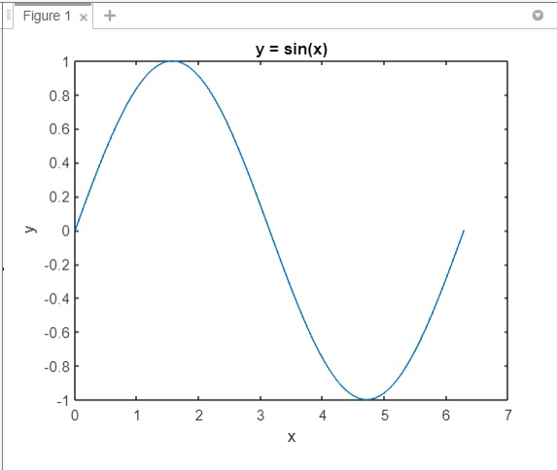

**Fig.: Output plot of a sine wave**

**Simulation:**

**Creating multiple sine wave plots:** We will plot 3 sine waves with phase differences.

**Command window input and explanation:**

x1 = 0:pi/100:2*pi; % x1 values will be from 0 to $2π$ radians with an interval of $π/100$

y1 = sin(x1); % Corresponding y1 values will be equal to sin(x1)

y2 = sin(x1 - 0.25); % Corresponding y2 values will be equal to sin(x1 – 0.25)

y3 = sin(x1 - 0.5); % Corresponding y2 values will be equal to sin(x1 – 0.5)

plot(x1,y1,x1,y2,x1,y3); % Plotting y1,y2 and y2 with respect to x1 each

xlabel('x'); % The xlabel() function is used to label the X axis with a text

ylabel('y'); % The ylabel() function is used to label the Y axis with a text

title('y1= sin(x1), y2= sin(x1-0.25), y3= sin(x1-0.5)'); %To show the title

text(6.38, 0,'y1'); % Putting a text at (6.38, 0) position

text(6.38, -0.2,'y2'); % Putting a text at (6.38, -0.2) position

text(6.38, -0.4,'y3'); % Putting a text at (6.38, -0.4) position

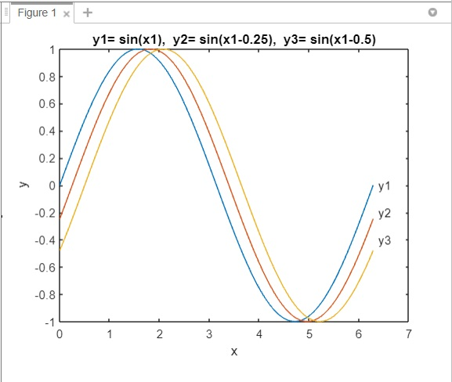

**Fig.: Plotting 3 sine waves**

**Simulation:**

**Controlling axes:** We will plot a cosine wave with specific maximum and minimum values for the axes.

**Command window input and explanation:**

t = -pi:(pi/100):pi; % t values will be from -π to π radians with an interval of (π/100)

s = cos(t); % Corresponding s values will be equal to cos(t)

plot(t,s); % Plotting the graph

axis([-pi pi -1 1]) % Setting the min and max ends for the x and y axes

xlabel('-\pi \leq t \leq \pi') % \leq is used to generate the less-equal sign (<=)

ylabel('s'); % Label of the y axis

title('s = cos(t)') ; % Adding a title

text(-1.5, -0.5,'Cosine wave with controlled axes'); % Adding a text at a specific position

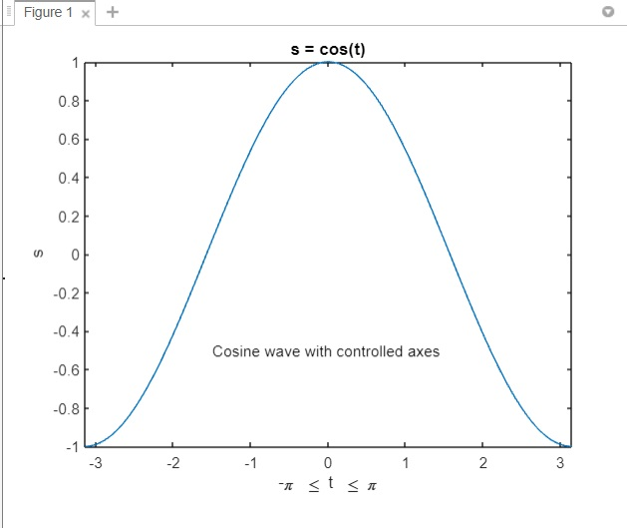

**Fig.: Plotting a cosine wave with controlled axes**

**Simulation:**

**Creating a line plot with markers:** We will plot 2 cosine waves with ‘-’ and ‘x’ signs as markers.

**Command window input and explanation:**x1 = 0:pi/20:6; % x1 values will be from 0 to 6 radians with an interval of π/20

y1= sin(x1); % Corresponding y1 values will be equal to sin(x1)

y2 = sin(x1 - 0.25); % Corresponding y2 values will be equal to sin(x1 - 0.25)

plot(x1,y1,'--',x1,y2,'-x') % Plotting with '-' and 'x' as markers

xlabel('x'); % The xlabel() function is used to label the X axis with a text

ylabel('y'); % The ylabel() function is used to label the Y axis with a text

title('y1= sin(x1), y2= sin(x1-0.25)'); %To show the title

text(0.2, 0.5,'y1'); % Putting a text at (0.2, 0.5) position

text(0.2, -0.2,'y2'); % Putting a text at (0.2, -0.2) position

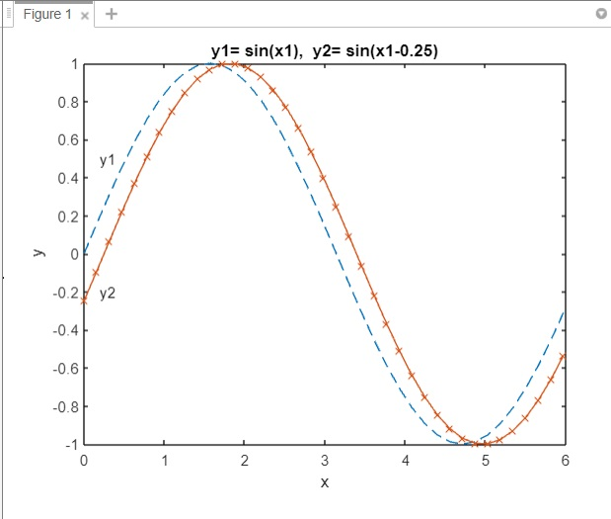

**Fig.: Plotting two sine waves with markers**

**Simulation:**

**Performance Lab Task for Lab Report:**

**(a) Sinusoid signals from student ID:**

Here,

$$x_{1}\left(t\right)=A_{1}\cos\left(2π\left(CDEF\right)t +j_{1}\right)$$

$$x_{2}\left(t\right)=A_{2}\cos\left(2π\left(CDEF\right)t +j_{2}\right)$$

My ID is 20-41840-1.

So, in AB-CDEFG-H format, A=2, B=0, C=4, D=1, E=8, F=4, G=0 and H=1.

Therefore, $A_{1}=$ AB=20, CDEF=4184, $A_{2}=$ GH=01, $j_{1}=$ DG $={10}^{°}$, $j_{2}={30}^{°}$

Now,

$$x_{1}\left(t\right)=20\cos\left(2π\left(4184\right)t + {10}^{°}×\frac{π}{{180}^{°}}\right)=20\cos\left(8368πt + \frac{π}{18}\right)$$

$$x_{2}\left(t\right)=\cos\left(2π\left(4184\right)t + {30}^{°}×\frac{π}{{180}^{°}}\right) = \cos\left(8368πt + \frac{π}{6}\right)$$

**(b) Now let’s plot the signals**  
  
  
**Script Code for x1 signal:**t=-0.0004:0.000002:0.0004; % t values from -0.0004s to 0.0004s with interval of $2×{10}^{-6}s$

% We have taken samples every $2×{10}^{-6} seconds$  
% Here time period of x1(t) = $\frac{2π}{8368π}$ => $2.39× {10}^{-4}$ seconds > 20 $×2×{10}^{-6}$ seconds

x1= 20*cos(8368*pi*t+(pi/18)); % Cosine signal

plot(t,x1) ; % Plotting the signal

axis([-0.0004 0.0004 -25 25]); % Setting up the axes

xlabel('-4/10000 \leq t \leq 4/10000','fontweight','bold','fontsize',14); %x axis label in bold text

ylabel('x1(t)','fontweight','bold','fontsize',14); %y axis label in bold text

title('x1 wave','fontsize',14) %Showing the title in bold text

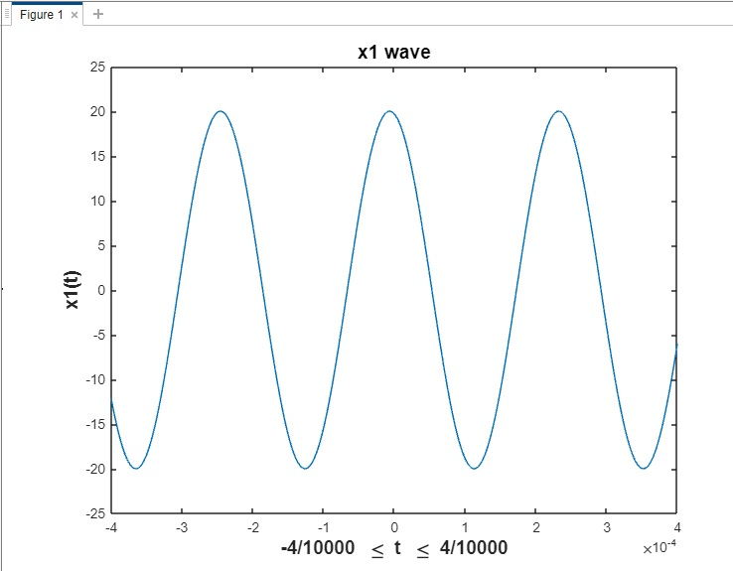

**Fig.: Plot of x1 signal**

**Script Code for x2 signal:**t=-0.0004:0.000002:0.0004; % t values from -0.0004s to 0.0004s with interval of $2×{10}^{-6}s$

% Thus we have taken samples every $2×{10}^{-6} seconds$

% Here time period of x1(t) = $\frac{2π}{8368π}$ => $2.39× {10}^{-4}$ seconds > 20 $×2×{10}^{-6}$ seconds

x2= cos(8368*pi*t+(pi/6));

plot(t,x2,’r’) ; % Cosine signal(red)

axis([-0.0004 0.0004 -5 5]); % Setting up the axes

xlabel('-4/10000 \leq t \leq 4/10000','fontweight','bold','fontsize',14); %x axis label in bold text

ylabel('x2(t)','fontweight','bold','fontsize',14); %y axis label in bold text

title('x2 wave','fontsize',14); %Showing the title in bold text

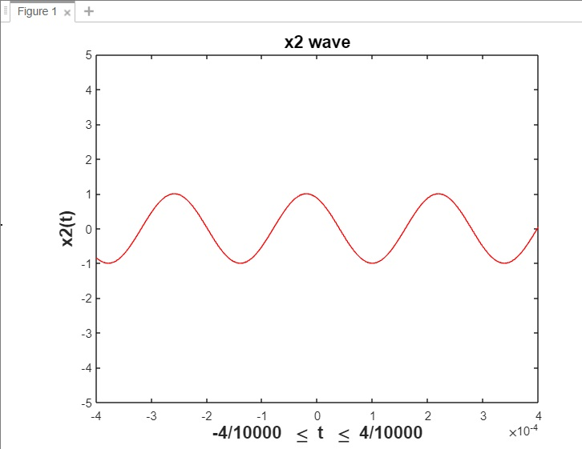

**Fig.: Plot of the x2 signal**

**(c) For the signal $x_{1}$,**

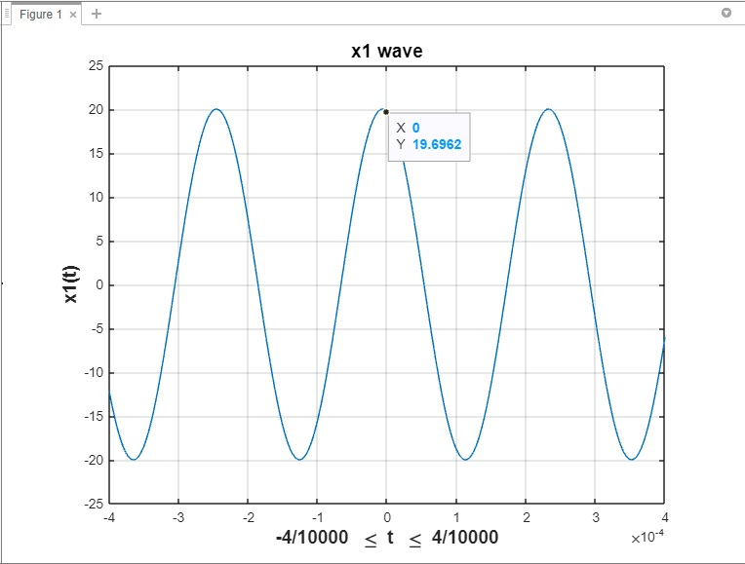 $x_{1}\left(t\right)=20\cos\left(8368πt + \frac{π}{18}\right)$; Amplitude = 20 and $x_{1}\left(0\right)=20\cos\left( \frac{π}{18}\right)=19.696$  
  
  
  
The above values of amplitude=20 and $x_{1}\left(0\right)= 19.696$ match with the plot in MATLAB. We can observe that the peak of the cosine wave $x_{1}$ is 20 and the phase at t=0 is 19.6962

**Fig.: Plot of x1 signal**

**For the signal $x_{2}$,**

$$x_{2}\left(t\right)=\cos\left(8368πt + \frac{π}{6}\right); Amplitude = 1 and x_{2}\left(0\right)=\cos\left( \frac{π}{6}\right)=0.866$$

Again, the above values of amplitude=1 and $x_{2}\left(0\right)= 0.866$ match with the plot in MATLAB. We can observe that the peak of the cosine wave $x_{2}$ is 1 and the phase at t=0 is $0.866025$.

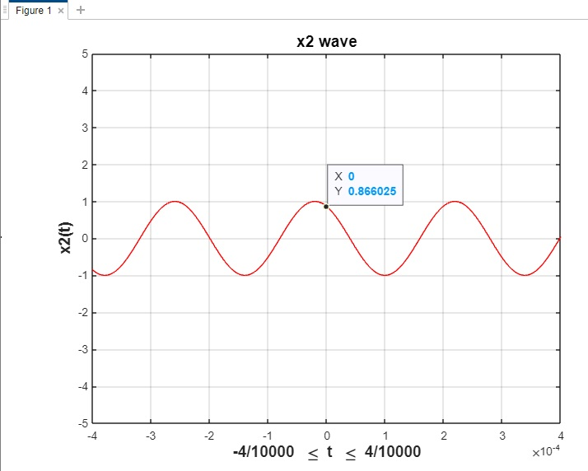

**Fig.: Plot of x2 signal**

**(d) Putting these two plots in the same window:**    
  
**Code:**t=-0.0004:0.000002:0.0004; % t values from -0.0004s to 0.0004s with interval of 2×10^(-6) s

subplot(3,1,1); % 1st plot of the 3x1 window

x1= 20*cos(8368*pi*t+(pi/18)); % Cosine signal

plot(t,x1) ; % Plotting the signal

axis([-0.0004 0.0004 -25 25]); % Setting up the axes

xlabel('-4/10000 \leq t \leq 4/10000','fontweight','bold','fontsize',14); %x axis label in bold text

ylabel('x1(t)','fontweight','bold','fontsize',14); %y axis label in bold text

title('x1 wave','fontsize',14) %Showing the title in bold text

subplot(3,1,2); % 2nd plot of the 3x1 window

x2= cos(8368*pi*t+(pi/6));

plot(t,x2,'r'); % Cosine signal

axis([-0.0004 0.0004 -5 5]); % Setting up the axes

xlabel('-4/10000 \leq t \leq 4/10000','fontweight','bold','fontsize',14); %x axis label in bold text

ylabel('x2(t)','fontweight','bold','fontsize',14); %y axis label in bold text

title('x2 wave','fontsize',14); %Showing the title in bold text

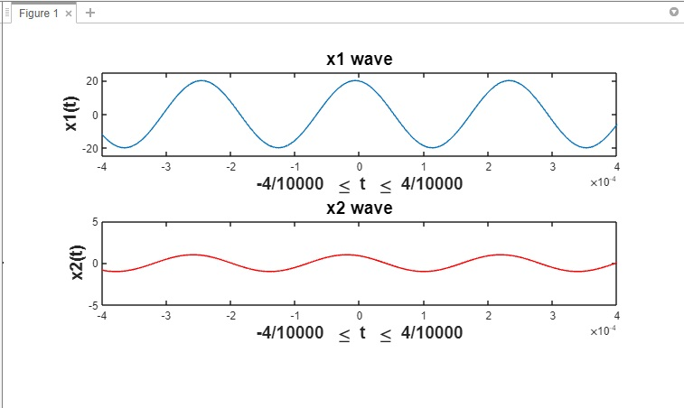 **Fig.: 3-panel sublot with both the signals**

**(e) Showing the signals along with their summation:**    
  
**Code:**% Following the previous code

subplot(3,1,3); % 3rd plot of the 3x1 window

x3=x1+x2; % sum of two previous signals

plot(t,x3,'g'); % Cosine signal ('g' represents green)

xlabel('-4/10000 \leq t \leq 4/10000','fontweight','bold','fontsize',14); % x axis label in bold text

ylabel('x3(t)','fontweight','bold','fontsize',14); % y axis label in bold text

title('x3 = x1 + x2','fontsize',14) %Showing the title in bold text

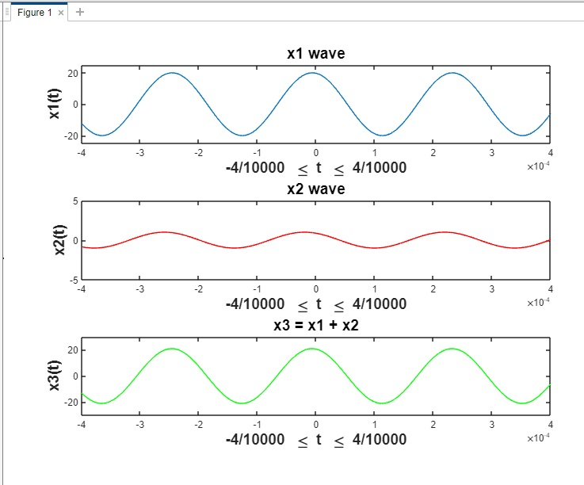

**Fig.: 3-panel sublot with all 3 signals**

**(e) Showing the annotations:**

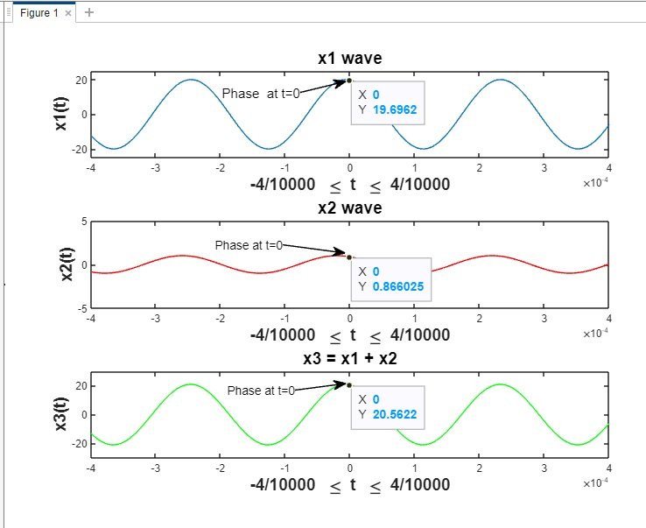

**Fig.: All the plots with annotations**

**Results and Discussion:** We have successfully demonstrated various graphical tasks as assigned to us for this experiment like sinusoid plotting, multiple plots, plots with markers, signal addition etc. In the latter problems we had to take miniscule intervals to get accurate results.

**Conclusion:**  We can say that we have been successful in terms of familiarizing ourselves with the basics of the MATLAB software for communication engineering and our work can be evaluated from this lab experiment report.

**References:**

1. MATLAB user guide.

2. Prof. Dr.-Ing. Andreas Czylwik, “MATLAB for Communications”  
3. AIUB Student Lab Manual